Inclusive entrepreneurship: necessary, right and rewarding.
The key to success for smoother work placements of new recruits
Many companies are struggling with a faltering influx of new employees. At the same time many vulnerable people, available to start work immediately, encounter too many difficulties in finding the path to the job market. For a smoother match with these candidates, JobRoad puts no less than 4 partners. Your search for new talent becomes so much more efficient through our network with Voka, the Chambers of Commerce, VDAB, social service providers, Travi, temporary employment agencies and the support of various authorities. So you are endorsed by the major players in the job market. Your collaboration with JobRoad is also a conscious choice for inclusive entrepreneurship.
JobRoad has started rolling out this network in various regions of Flanders. Your business/organisation can participate at no cost.
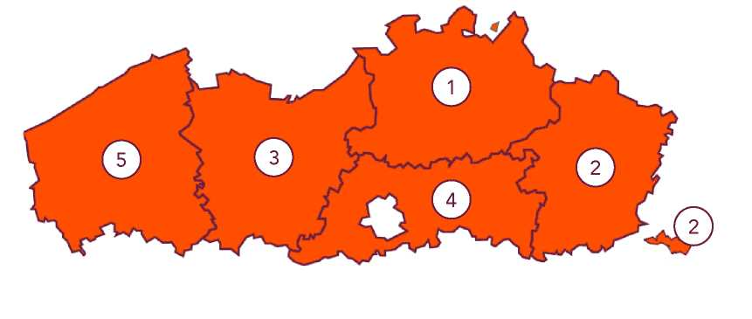

1. Antwerp | 2. Limburg | 3.East-Flanders | 4. Flemish Brabant | 5.West Flanders
Antwerp | Tongeren | Ghent  Gent | Vilvoorde | Bruges
Mechelen | Maasmechelen | Aalst | Leuven | Roeselare
Lier | Hasselt/Genk | Oudenaarde | Ternat | Oostende
Geel | Tessenderlo | Deinze |  | Harelbeke
Kuurne
Lendelede

For more information about our unique approach and the calendar, visit www.jobroad.be

Focus on human capital
JobRoad focuses on companies that cherish an inclusive employee policy and take a broader view of corporate social responsibility.
“Everything became much easier thanks to JobRoad. Within two weeks I had a job prospect. ”
Sameh Madanikochak, budget planner at Veronapro
“It is high time for practical solutions. The JobRoad network project is a good example of such a solution.”
Peter De Cuyper, research leader KU Leuven
“JobRoad's strength lies in its ability to find suitable candidates for well-defined job vacancies. They call on their broad network for this preliminary process, thus ensuring fast integration through work. ”
Bert Mons, managing director VOKA West Flanders
“We must do our utmost to create job opportunities. It provides income, structure, integration and emancipation. JobRoad is a key player and their broad network and close partnerships can help make a difference. ”
Hilde Crevits, Flemish minister of Work and Social Economy
For more information about our approach and projects visit www.jobroad.be.

This is what JobRoad can do for your business/organisation

Project edition:
Do you need new employees? Would you like to offer opportunities to talented people not first in line in the job market? Visit www.jobroad.be to find out which regions and projects are about to be included in JobRoad's network, or contact Eliese Kublik or Nathalie Galland for more information (see contact details below).
Free service

Matchmaking:
Do you wish the JobRoad's tailor-made approach for your company? For more information, please contact Eliese Kublik or Nathalie Galland (see contact details below).
Payable service

Workshops ‘inclusion in the work place:
Our team offers a variety of professional workshops to encourage the work place and/or certain employees within your company/organisation to more inclusive thinking and a better approach to new colleagues and situations. For more information, please contact Laura Bogaert (see contact details below).
Payable service

Ambassadors:
Ambassadors support the daily operations of the JobRoad organisation. Become an ambassador and help us to promote inclusive entrepreneurship. You will automatically enjoy many benefits and help decide on the yearly strategic objectives during our annual meeting. For more information, please contact Joachim Commeene (see contact details below).

For any questions or comments please do not hesitate to contact us.

Follow us on social media o © © o Visit our website www.jobroad.be
Project editions
Nathalie Galland
Project Manager Antwerp,
Limburg & Flemish Brabant 0473 81 45 18
nathalie.galland@jobroad.be
Eliese Kublik
Project Manager
East and West Flanders
0485 21 51 04
eliese.kublik@jobroad.be
Workshops:
Laura Bogaert
Project Coordinator 047 3 30 69 1 5 laura.bogaert@jobroad.be
Ambassadors:
Joachim Commeene
Chief Employability Officer 0477 63 02 88
joachim.commeene@jobroad.be

